Student Achievement and Retention Rates Dashboard

Contents

# Introduction

# Dashboard Purpose & Audience

# Visualisations

# Actionable Business Insights

# Concluding Remarks

# References

# Appendix

# Introduction

This document outlines the purpose and application of the ‘Student Achievement and Retention Rates’ dashboard. It explains the dashboard's visualisations and provides examples of how it can be used to gain insights and make data-driven decisions related to student achievement and retention rates.

# Dashboard Purpose & Audience

The primary purpose of the dashboard is to summarise student achievement and retention rates for a UK further education (FE) college, with student achievement defined as the number of learners who successfully completed their qualification and retention as the number of students who either finished or are still continuing their course. These metrics are significant for FE providers, as the Department for Education (2023) highlights that student achievement and retention rates are key indicators of the success of educational institutions in the UK.

With this in mind, the dashboard comprises of three pages, using data from an FE provider:

* Student Achievement Rates (figure 1): Summarises student achievements and benchmarks these against business key performance indicators.
* Student Retention Rates (figure 2): Summarises student retention and benchmarks this against business key performance indicators.
* Leavers, Achievement, and Retention Trends (figure 3): Visualises fluctuations in student leavers, achievement rates, and retention rates over time.

At first glance, the dashboard may be viewed as a strategic dashboard, primarily used to compare achievement and retention rates against business KPIs to gauge performance (Sarikaya, et al., 2018). Though, it also offers analytical functionality (demonstrated in the ‘Visualisations’ section), including drilldowns, filtering, and trend analysis (figure 3). Thus, it can also function as an analytical dashboard (Sarikaya, et al., 2018).

In terms of the dashboard’s audience, users may vary based on the context of its use (as detailed in the ‘Visualisations’ section). However, it is primarily intended for upper management stakeholders of an FE provider, who would be most concerned with monitoring achievements and retention performance. This includes stakeholder groups such as school governors, executive management, curriculum directors, and curriculum managers.

# Visualisations

The visuals chosen for the dashboard were selected with the intention to best represent each data point, and the specific needs of the intended users in mind. Card graphics (figures 4 & 9) were used to provide the highest-level overview of student achievement and retention numbers at a glance. Recognising that Western audiences typically read from top-left to bottom-right, the most important figures were placed as large cards at the top of the dashboard pages, ensuring they are acknowledged first. Consequently, these card visuals are ideal for school governors and executive management stakeholders, who are primarily focused on the overall performance of the college.

Bar graphs were used to display student achievement and retention rates, aggregated by sector subject area (figures 5 & 10) and qualification level (figures 6 & 11). This visualisation was chosen because it facilitates easy comparison of performance across different sector subject areas and qualification levels. For example, figure 6 clearly shows that level 1 qualifications have the lowest achievement rates among the qualification levels and fall short of the college KPI target of 80% achievement (figure 4).

Since there are two hierarchal levels of sector subject areas, drill-down feature was added to enable users to navigate from subject area 1 to subject area 2. For instance, in figure 18, drilling down into the ‘Business Administration and Law’ area reveals its respective subject area 2s; all other visuals on the dashboard page also filter down to this specific subject area as well. This example highlights that the ‘Accounting and Finance’ area 2 is responsible for lowering the overall achievement rate of the area, while the other area 2s exceed the college KPI for achievement. This case demonstrates how the dashboard can be utilised by analytical audiences, such as curriculum directors, who may want to drill down to monitor the performance of their specific curriculum areas.

Donut charts were employed to represent the distribution of student achievers and leavers by age group in figures 7 and 12, respectively. This visualisation was chosen as donut charts are effective for displaying proportions within categories that have few distinct values (Cai, et al., 2018). Given that there are only two age group categories, the donut chart makes it easy to compare the distribution of achievers and leavers between these two age groups.

To visualise changes in leavers, achievement, and retention over academic years, a combination line chart was selected (figure 3). Line charts are particularly useful for highlighting peaks and troughs in data over time, making it easy for users to observe trends (Heer, Kong, and Agrawala, 2009). This chart caters to both general users, who may simply want to track overall trends for the college, and analytical users, who can gain more detailed insights through filtering.

For example, when filtering the visual to display only entry-level qualifications, a significant drop followed by a peak is observed across all three metrics in 2021/22 and 2022/23, respectively. This pattern could be attributed to the disruption of education caused by COVID-19 in 2021/22 (Andres, et al., 2023), followed by a rebound in 2022/23, as illustrated in figure 19.

Mobile views were created for all dashboard pages (figures 15, 16, and 17), enabling access on various devices beyond computer monitors, including smartphones. This feature is particularly beneficial for stakeholders who are frequently off-site or need to travel for business, such as executive management, who may not always have access to a computer. In these situations, the dashboard can be easily viewed on a portable device of their choice.

# Actionable Business Insights

By exploring the dashboard and interacting with its visual elements, users can reveal various actionable business insights. For instance, the five sector subject areas with the lowest retention rates can be identified. This can be achieved by navigating to the ‘Student Retention Rates’ page, drilling down to the subject area twos in the bar chart, sorting the chart by ‘Retention%’ in ascending order, and finally selecting the top five subject areas on the graph (figure 20).

This view of the dashboard reveals that these five subject areas collectively had 1,614 student leavers, 273 withdrawals, and a retention rate of 83.17%, falling short of the college’s 90% retention target by 6.29%. Moreover, the tooltip in figure 20 indicates that although the ‘History’ subject area performed the poorest, with a retention rate of 76.92%, it had relatively few learners; only 52 leavers and 17 withdrawals. Therefore, when assessing a subject area’s impact on overall college retention rates, the number of leavers and withdrawals should also be considered.

Additionally, figure 20 shows the ‘Retention%’ by Qualification Level for these five subject areas, highlighting that only entry-level qualifications exceed the business retention KPI. The other levels fall short, with Level 4 qualifications having the lowest retention.

With this information, upper management stakeholders can be updated on the retention rates of these subject areas, enabling them to provide support for improving student retention. They could collaborate with the staff from these curriculum areas, such as Curriculum Managers, to investigate issues affecting retention more closely. For instance, gathering feedback from learners in the Level 4 qualifications of these areas could identify challenges they may be facing with their education.

Additionally, this information could be cross-referenced with other potentially relevant reports to deepen the understanding of factors influencing retention. For example, attendance data could be cross-referenced, as attendance is one factor that can impact student retention (Bowen, 2005).

The ‘Leavers, Achievement, and Retention Trends’ page can be analysed and compared between the 16-19 and 19+ age groups. This can be performed by simply filtering this dashboard page by each age group (figure 21).

For the 16-19 learners, it can be observed from this that the number of leavers grew steadily from around 6,000 in 2018/19 to almost 7,000 in 2020/21 but dropped to just over 6,400 in 2022/23. ‘Retention%’ over time for 16-19 students only changed slightly over time, starting at around 94% in 2018/19, then having slight decreases and growth over the years, and finishing at under 90% in 2022/23. ‘Achievement%’ for this age group started just above 80% in 2018/19, remained mostly static until 2021/22 where this dropped to around 75%, then recovered back to 80% in 2022/23.

For the 19+ students, leavers started at over 5,000 leavers in 2018/19, dropped the following academic year, then rose back to around 5,000 leavers in 2020/21. However, leavers then dropped to under 3,000 in 2021/22 then around 2,000 in 2022/23. ‘Retention%’ for these students started at over 95% then gradually decreased until 2021/22 at around 87% but rose to around 91% in 2022/23. ‘Achievement%’ followed a similar pattern, starting at 90% in 2018/19, decreasing until 2021/22 at around 82%, then rose to around 86% in 2022/23.

An actionable insight from these numbers could be to investigate whether the decline across all metrics for both age groups in 2021/22, followed by a recovery in 2022/23, is linked to the impact of COVID-19 on education in the UK (Andres, et al., 2023). If this is the case, it could be valuable for the college to explore how another pandemic might affect student outcomes and what measures could be taken to mitigate these impacts.

Another action point could be to further analyse the decline in adult retention, as this trend did not occur among 16-19 students. Although adult retention improved somewhat in 2022/23, it is undesirable for education providers when fewer learners complete their education. Therefore, it could be valuable for the business to identify any specific causes behind this decline to prevent further reductions in retention.

From the ‘Student Achievement Rates’ screen, it can be observed that level 2 qualifications have the highest achievement rates. By selecting level 2 on the bar chart (figure 22), it is revealed that these qualifications have an achievement rate of 85.79%, exceeding the college’s achievement target KPI by 5.79%.

Given the success of these courses, it may be beneficial for the business to identify the factors contributing to these high achievement rates. For instance, gathering feedback from the curriculum staff teaching these courses could uncover common practices that could be implemented in other areas. Additionally, identifying these successful courses could inform management’s decisions on which courses to continue delivering in future academic years.

Another use for the ‘Leavers, Achievement, and Retention Trends’ page could be to analyse these trends for specific sector subject areas. For example, in figure 23, when filtered by ‘Arts, Media, and Publishing,’ the page shows that the number of leavers in this area has nearly doubled over time, rising from just under 400 in 2018/19 to almost 800 in 2022/23.

This use case may be particularly valuable for curriculum managers who want to monitor the performance of their specific areas over time. Additionally, these stakeholders could use this to predict the number of achievers/retained students they might expect in the current or future academic year. For instance, with ‘Arts, Media, and Publishing’ showing a consistent retention rate of around 88% over the past three years, if there are 800 students enrolled this academic year, they can expect approximately 704 leavers.

# Concluding Remarks

The ‘Student Achievement and Retention Rates Dashboard’ was designed to summarise achievement and retention data for both general and analytical audiences within an FE education provider. The provided use cases exemplify how senior management can utilise the dashboard to monitor overall college performance, while also demonstrating how filtering and interaction enable more specific use by other stakeholders, including curriculum directors, for metrics such as achievement rates of particular subject areas. Consequently, the dashboard should deliver business value to an FE provider by facilitating data-driven decisions, such as determining which courses to continue delivering or highlighting which areas of the college require additional support.

# References

Andres, L., et al. (2023) ‘The Impact of COVID-19 on Education, Food & Play-Leisure and Related Adaptations for Children and Young People: International Overview’, *PANEX-Youth* [Online]. Available at: <https://discovery.ucl.ac.uk/id/eprint/10173372/> (Accessed 25th August 2024)

Bowen, E., et al. (2005) ‘Improving the quantity and quality of attendance data to enhance student retention’, *Journal of Further and Higher Education*, 29(4) [Online]. Available at: <https://doi-org.ezproxy.neu.edu/10.1080/03098770500353714> (Accessed 29th August 2024)

Cai, X., et al. (2018) ‘A study of the effect of doughnut chart parameters on proportion estimation accuracy’, *Computer Graphics Forum*, 37(6) [Online]. Available at: <https://doi.org/10.1111/cgf.13325> (Accessed 24th August 2024)

Department for Education (2023) *Education and training qualification achievement rates technical specification 2022 to 2023* [Online]. Available at: <https://assets.publishing.service.gov.uk/media/64de03b63fde6100134a542f/Education_and_training_qualification_achievement_rates_technical_specification_2022_to_2023_1.pdf> (Accessed 22nd August 2024)

Heer, J., Kong, N., and Agrawala, M. (2009) ‘Sizing the horizon: the effects of chart size and layering on the graphical perception of time series visualizations’, *Proceedings of the SIGCHI conference on human factors in computing systems* [Online]. Available at: <https://doi.org/10.1145/1518701.1518897> (Accessed 25th August 2024)

Sarikaya, A., et al. (2018) ‘What do we talk about when we talk about dashboards?’, *IEEE transactions on visualization and computer graphics*, 25(1) [Online]. Available at: <https://doi.org/10.1109/TVCG.2018.2864903> (Accessed 22nd August 2024)

# Appendix

Figure 1, Student Achievement Rates Dashboard Page

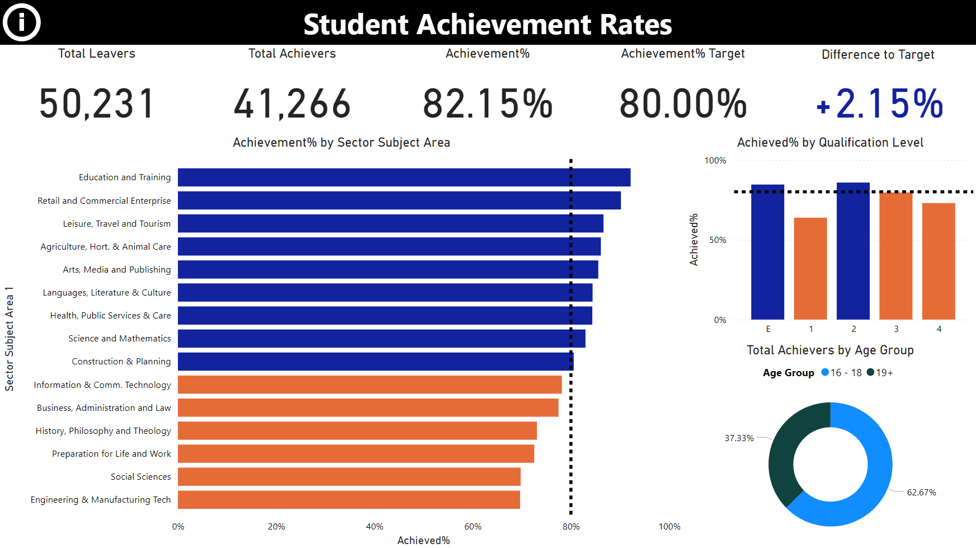

Figure 2, Student Retention Rates Dashboard Page

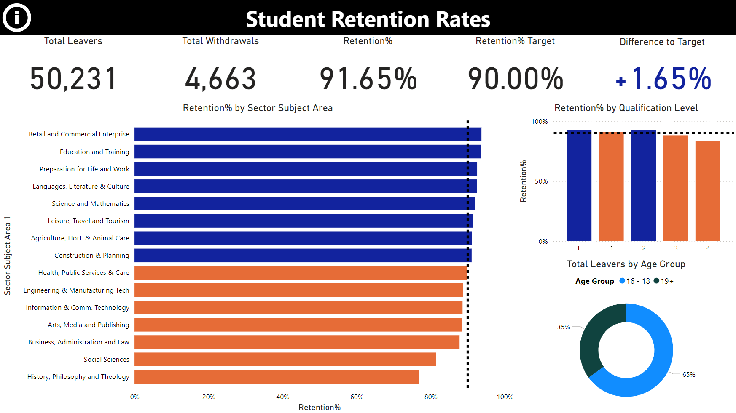

Figure 3, Leavers, Achievement, and Retention Trends Dashboard Page

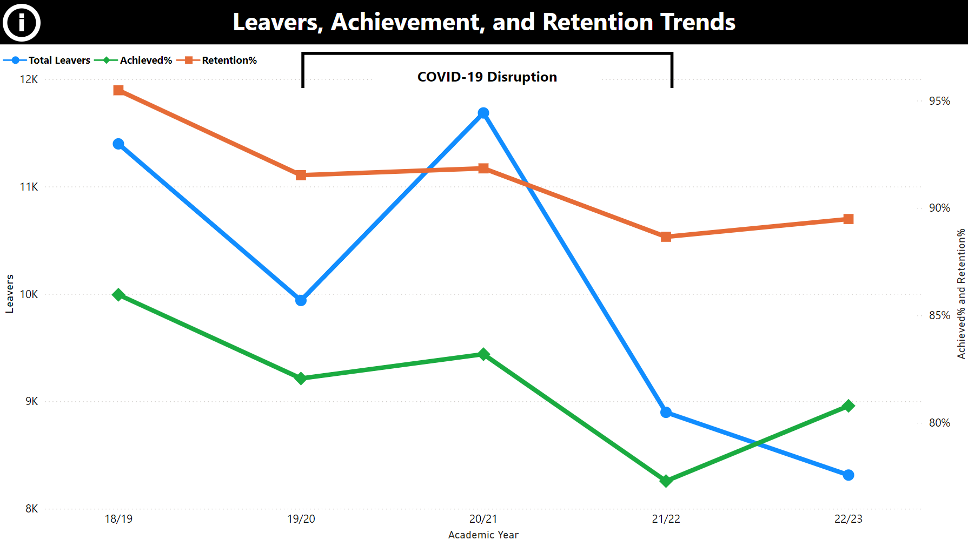

Figure 4, Student Achievement Rates Card Visuals

  
Figure 5, Achievement% by Sector Subject Area Bar Graph Including Tooltip

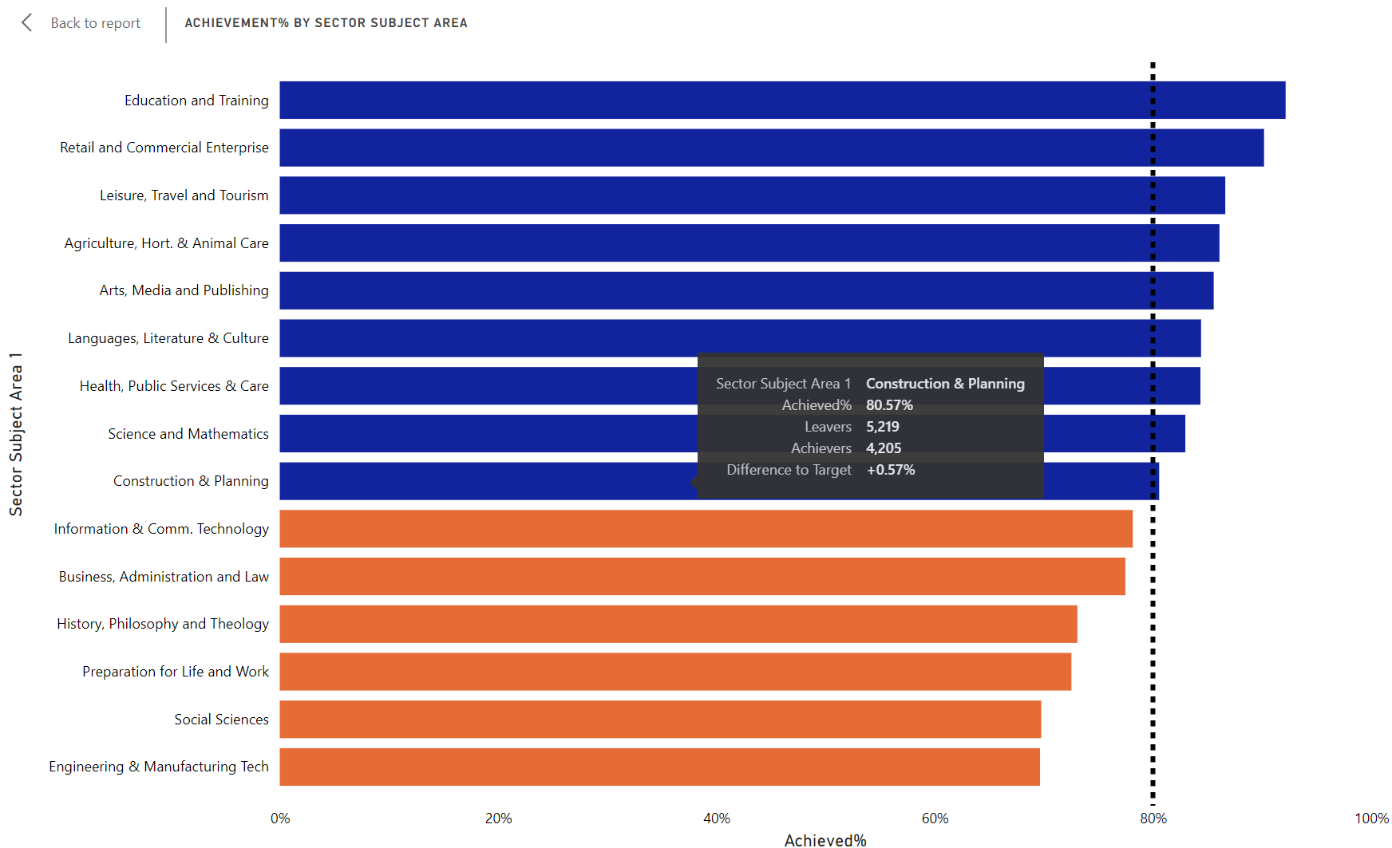

Figure 6, Achievement% by Qualification Level Bar Graph Including Tooltip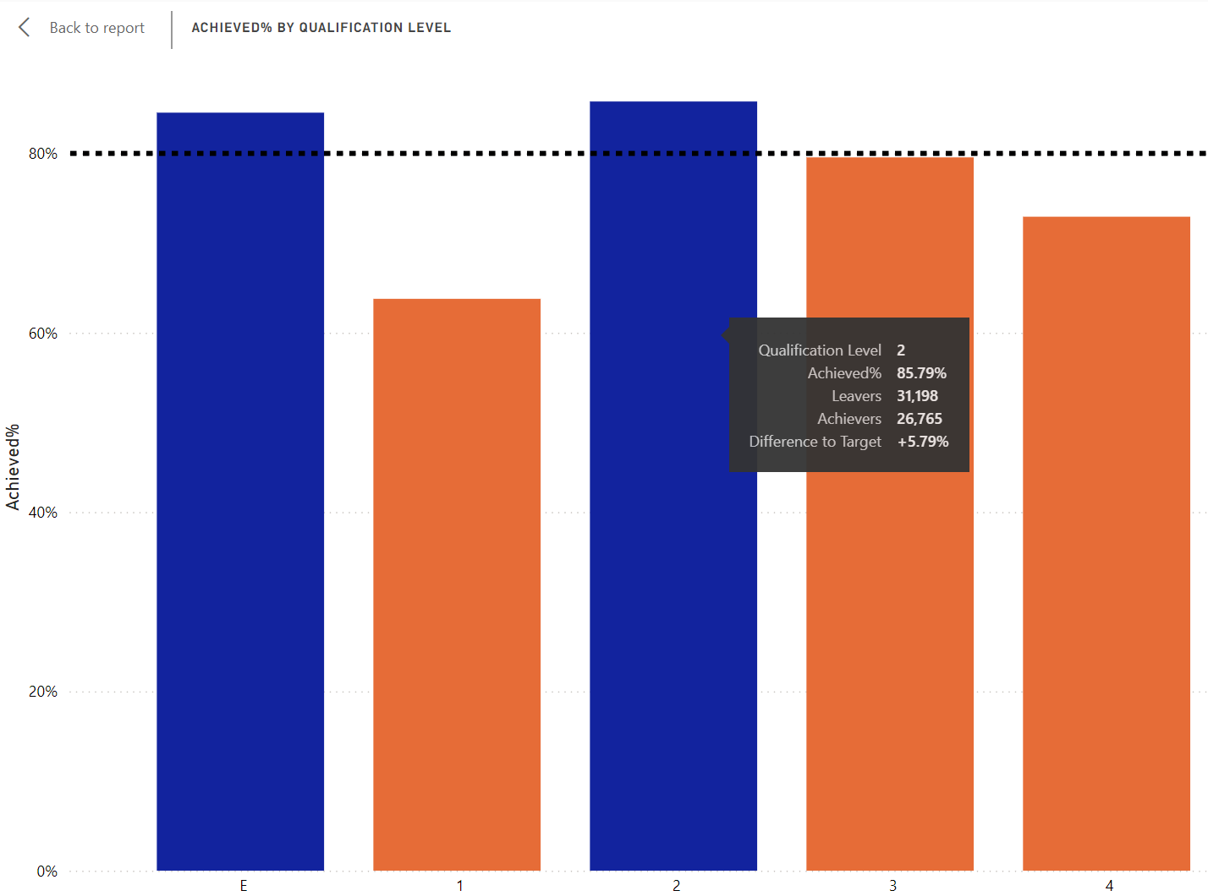

Figure 7, Total Achievers by Age Group Donut Chart Including Tooltip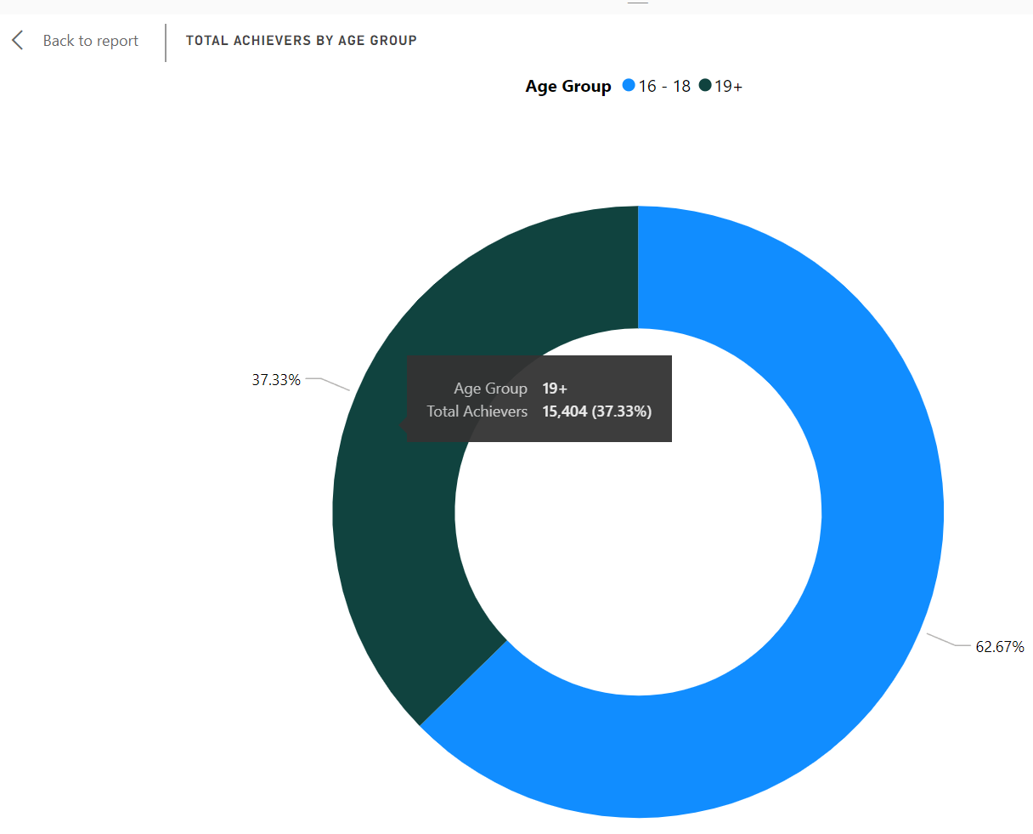

Figure 8, Student Achievement Rates Information Pane

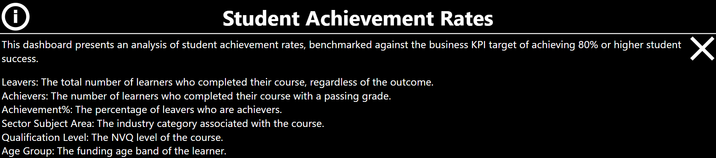

Figure 9, Student Retention Rates Card Visuals



Figure 10, Retention% by Sector Subject Area Bar Graph Including Tooltip

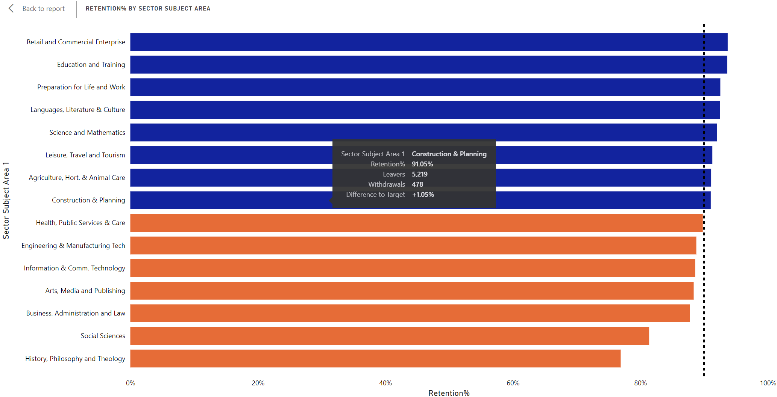

Figure 11, Retention% by Qualification Level Bar Graph Including Tooltip

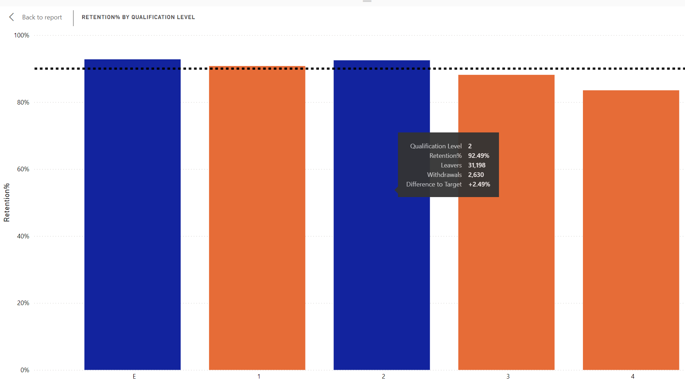

Figure 12, Total Leavers by Age Group Donut Chart Including Tooltip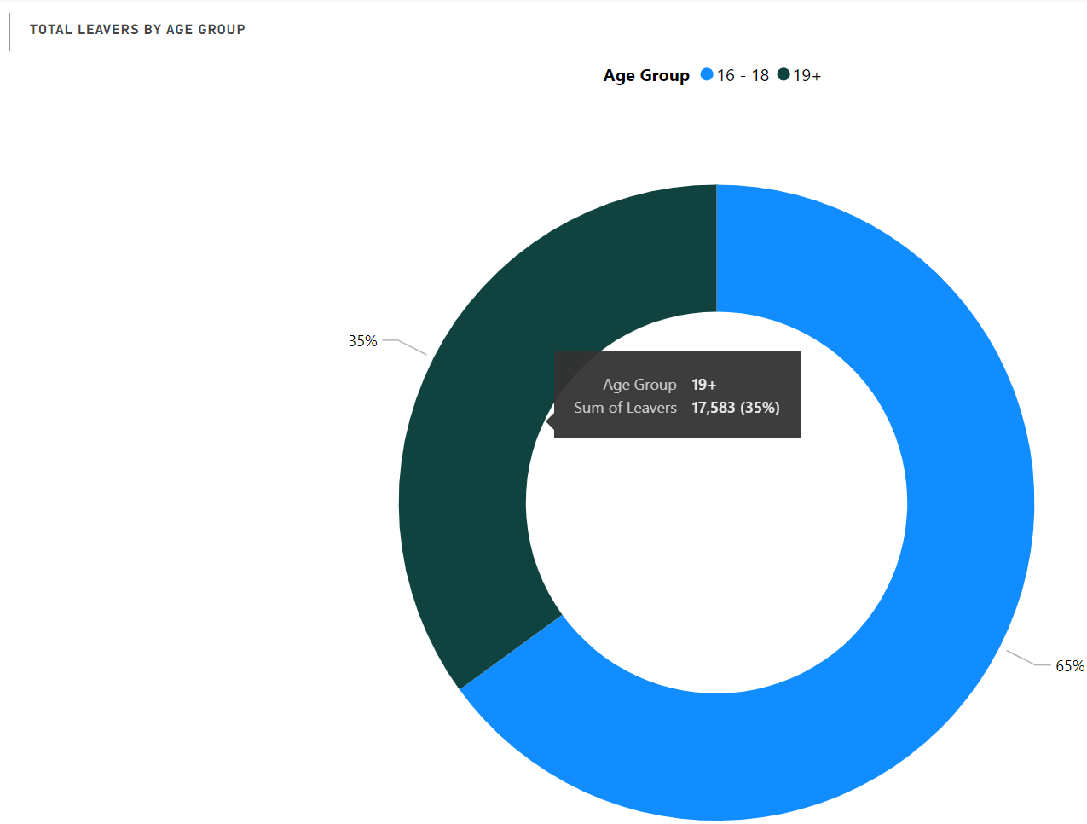

Figure 13, Student Retention Rates Information Pane

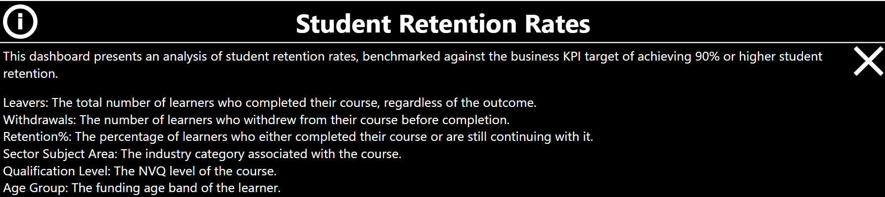  
Figure 14, Leavers, Achievement, and Retention Trends Information Pane

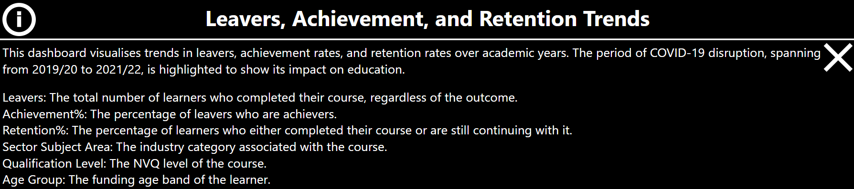  
Figure 15, Student Achievement Rates Mobile View

|  |  |
| --- | --- |
|  |  |

Figure 16, Student Retention Rates Mobile View

|  |  |
| --- | --- |
|  |  |

Figure 17, Leavers, Achievement, and Retention Trends Mobile View

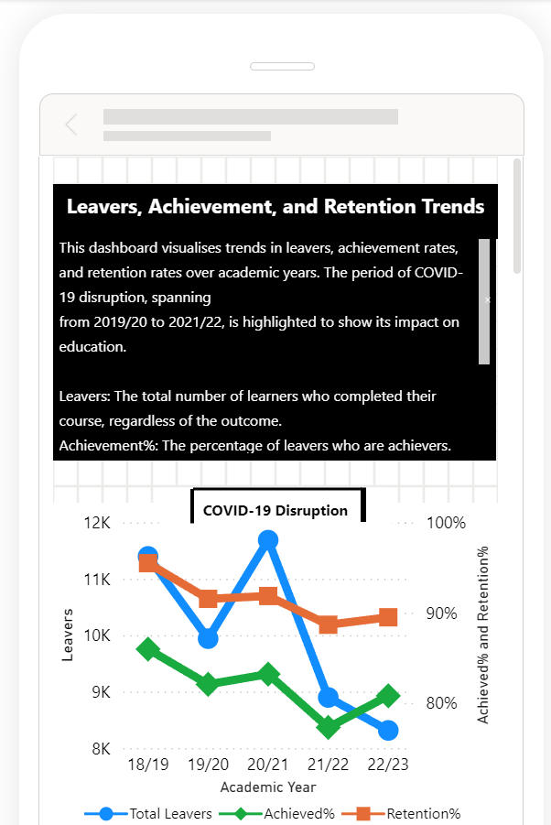

Figure 18, Drilling down on ‘Business Administration and Law’ Sector Subject Area on Student Achievement Rates Page

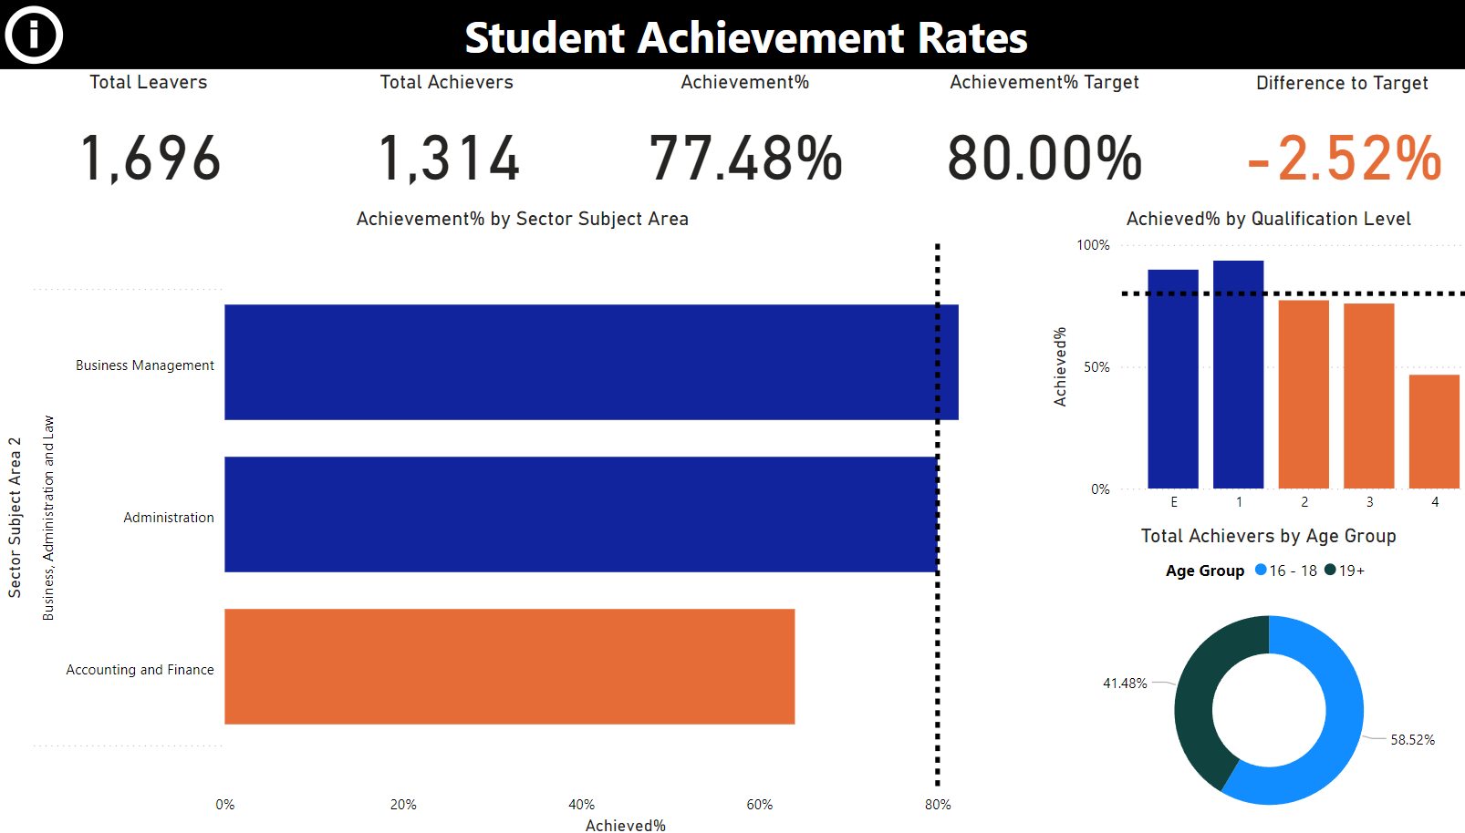

Figure 19, Leavers, Achievement and Retention Trends by Entry Level Qualifications Including Tooltip

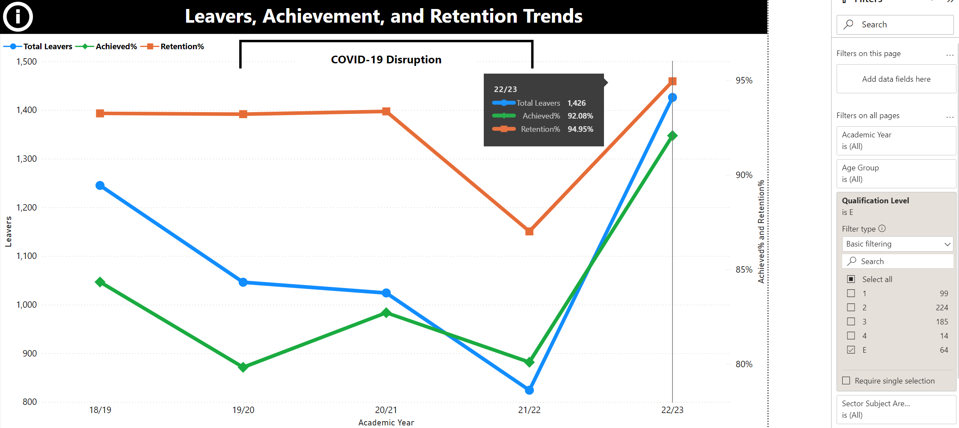

Figure 20, The Five Sector Subject Area Twos with the Lowest Retention Rates Including Tooltip

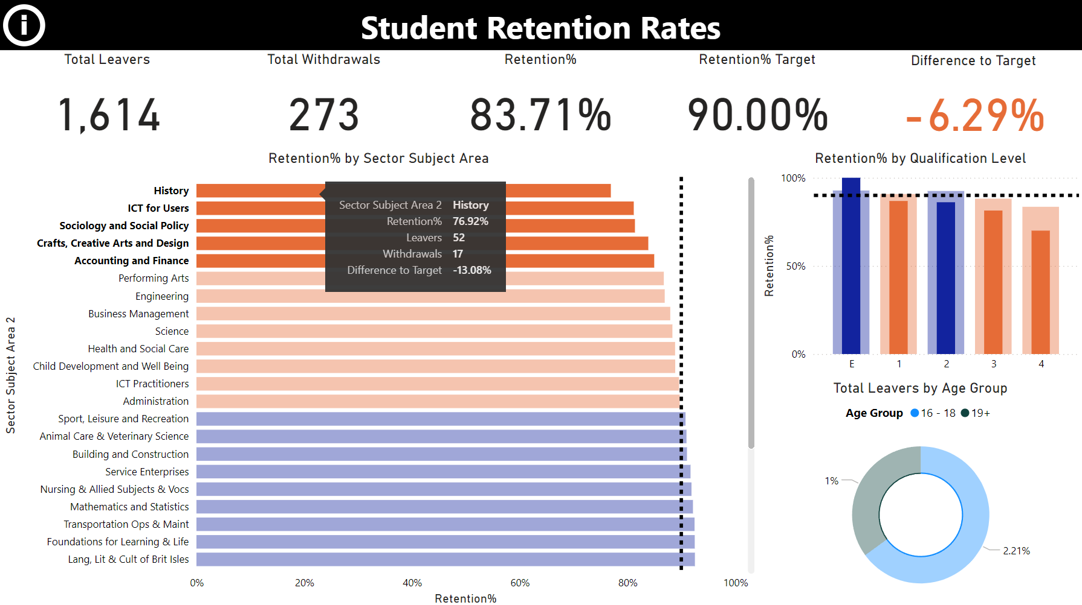

Figure 21, Leavers, Achievement, and Retention Trends by Age Group

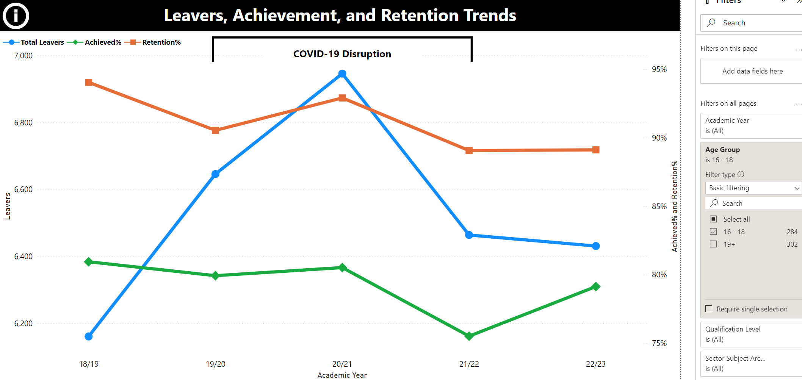

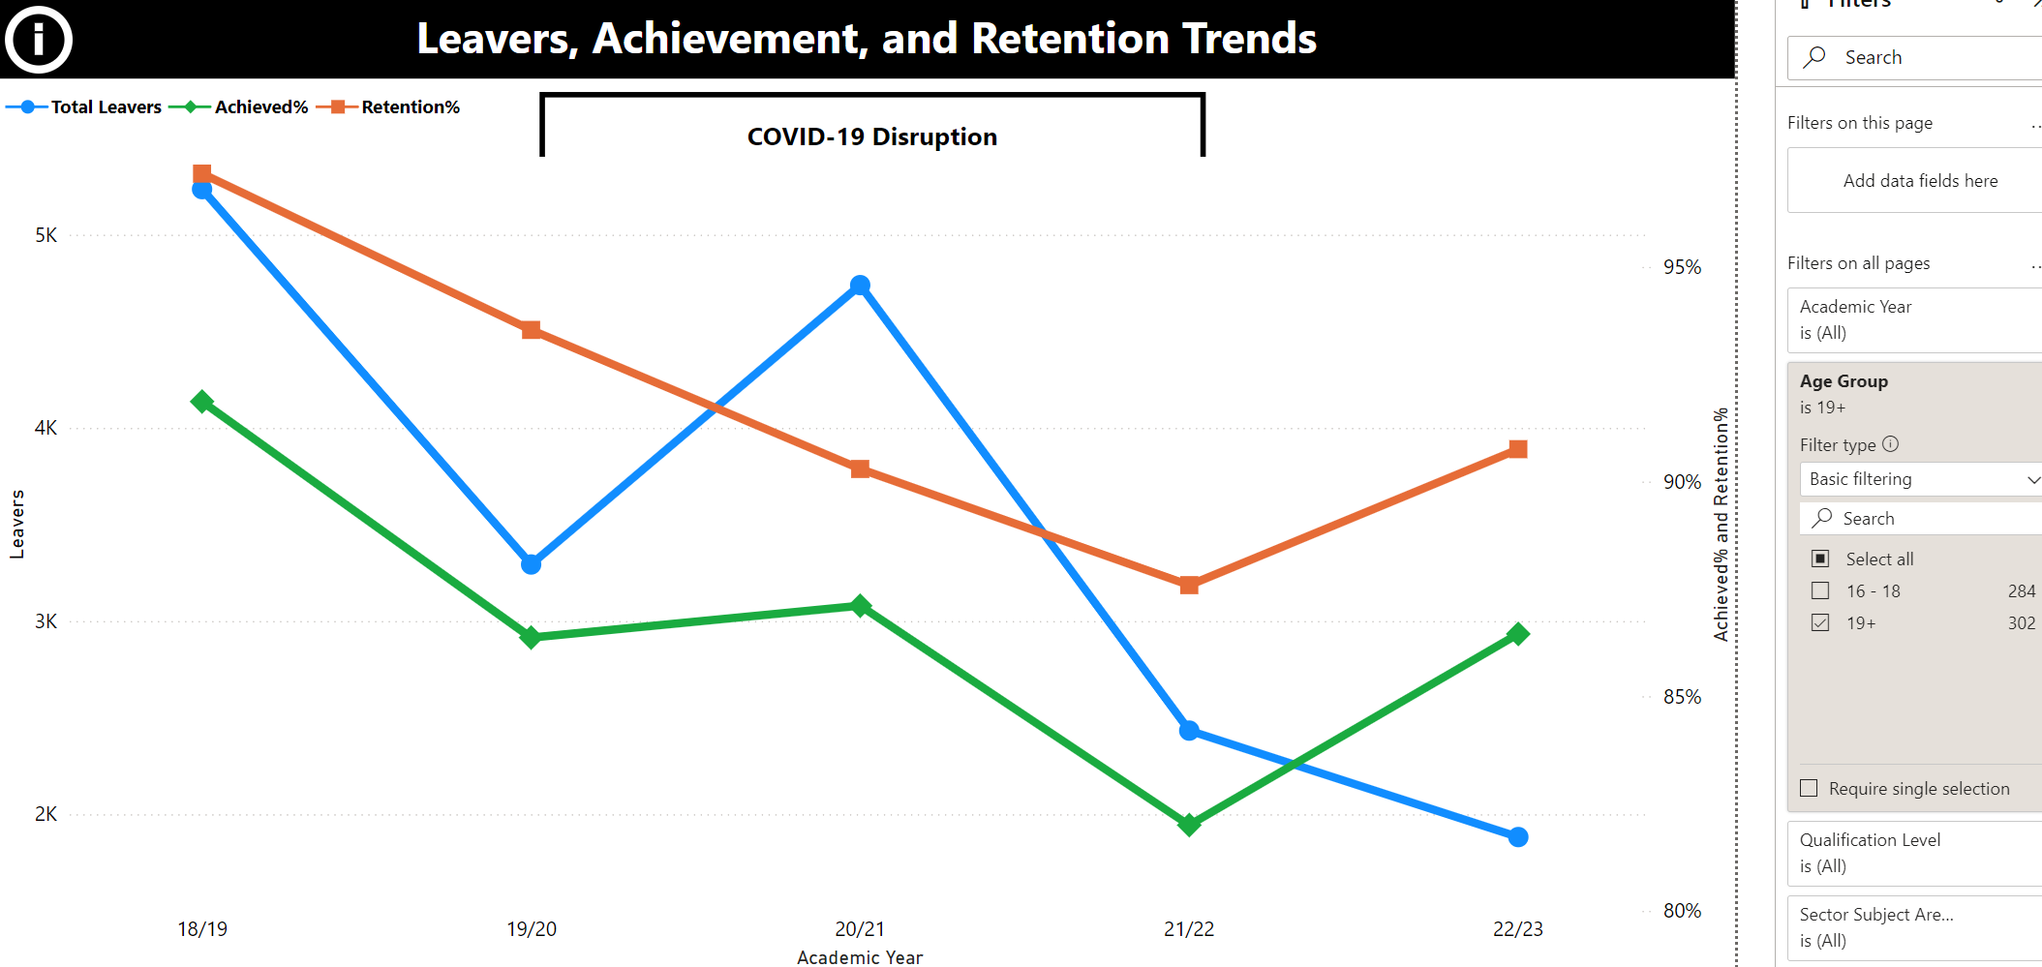

Figure 22, Achievement Rates of Level 2 Qualifications

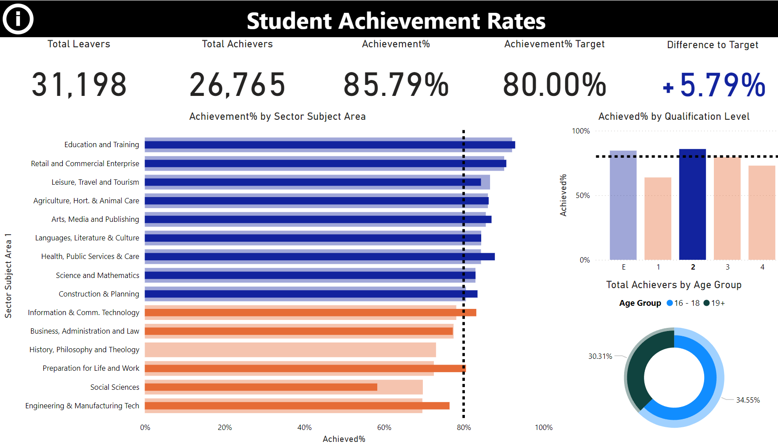

Figure 23, Arts Media and Publishing Trends

